Section I: Scenario Demographics

Scenario Title: | Pediatric Septic Shock
Date of Development: | 09/06/2015 (DD/MM/YYYY)
Target Learning Group: | Juniors (PGY 1 – 2) Seniors (PGY ≥ 3) All Groups

Section II: Scenario Developers

Scenario Developer(s): | Kyla Caners
Affiliations/Institution(s): | McMaster University
Contact E-mail (optional): | kcaners@gmail.com

Section III: Curriculum Integration

Learning Goals & Objectives
Educational Goal: | To allow learners to become more comfortable managing common issues associated with pediatric resuscitation.
CRM Objectives: | - Communicate effectively with team regarding orders and drug doses.  - Allocate resources appropriately to manage a distraught parent.
Medical Objectives: | - Recognize the need for early IO access in critically unwell child where iv unsuccessful.  - Initiate appropriate investigations and treatment for septic child. Specifically:  - Check capillary blood glucose.  - Administer IV antibiotics.  - Prioritize IV fluid pushes then vasopressors  - Recognize the need to intubate a septic child with altered LOC.

Case Summary: Brief Summary of Case Progression and Major Events
A 4 year-old girl is brought to the ED because she is “not herself.” She has had 3 days of fever and cough and is previously healthy. She looks toxic on arrival with delayed capillary refill, a glazed stare, tachypnea and tachycardia. The team will be unable to obtain IV access and will need to insert an IO. Once they have access, they will need to resuscitate by pushing fluids. If they do not, the patient’s BP will drop. If a cap sugar is not checked, the patient will seize. The patient will remain listless after fluid resuscitation and will require intubation.

References
Marx, J. A., Hockberger, R. S., Walls, R. M., & Adams, J. (2013). Rosen's emergency medicine: Concepts and clinical practice. St. Louis: Mosby.
http://circ.ahajournals.org/content/132/18_suppl_2/S526
http://www.rch.org.au/clinicalguide/guideline_index/Intraosseous_access/

Section IV: Scenario Script

A. Scenario Cast & Realism
Patient: | Pediatric Computerized Mannequin |  |  |  |  | Realism:  Select most important dimension(s) |  |  | Conceptual
 | Mannequin |  |  |  |  |  |  |  | Physical
 | Standardized Patient |  |  |  |  |  |  |  | Emotional/Experiential
 | Hybrid |  |  |  |  |  |  |  | Other:
 | Task Trainer |  |  |  |  |  |  |  | N/A
Confederates | Brief Description of Role
Mother | Can provide history. (To add a challenge for seniors, mother can become obstructive to care or extremely distraught.)
RN | To indicate when iv access cannot be established
B. Required Monitors
EKG Leads/Wires |  |  | Temperature Probe |  |  |  | Central Venous Line
NIBP Cuff |  |  | Defibrillator Pads |  |  |  | Capnography
Pulse Oximeter |  |  | Arterial Line |  |  |  | Other:
C. Required Equipment
Gloves |  |  | Nasal Prongs |  |  |  | Scalpel
Stethoscope |  |  | Venturi Mask |  |  |  | Tube Thoracostomy Kit
Defibrillator |  |  | Non-Rebreather Mask |  |  |  | Cricothyroidotomy Kit
IV Bags/Lines |  |  | Bag Valve Mask |  |  |  | Thoracotomy Kit
IV Push Medications |  |  | Laryngoscope |  |  |  | Central Line Kit
PO Tabs |  |  | Video Assisted Laryngoscope |  |  |  | Arterial Line Kit
Blood Products |  |  | ET Tubes |  |  |  | Other: masks, gowns, gloves for droplet precautions
Intraosseous Set-up |  |  | LMA |  |  |  | Other:
D. Moulage
None required.

E. Approximate Timing
Set-Up: |  | 3 min |  | Scenario: | 12 min |  |  | Debriefing: |  | 20 min

Section V: Patient Data and Baseline State

A. Clinical Vignette: To Read Aloud at Beginning of Case
A 4-year-old girl presents to your pediatric ED. Her mother states she is “not herself” and seems “lethargic.” She’s had a fever and a cough for the last three days. Today she just seems different. She was brought straight into a resus room and the charge nurse came to find you to tell you the child looks unwell.
B. Patient Profile and History
Patient Name: Rebecca Smythe |  |  |  |  |  | Age: 4 |  |  |  |  |  |  |  | Weight: 20kg
Gender: M F |  |  |  |  |  | Code Status: Full
Chief Complaint: Lethargic
History of Presenting Illness: Fever and cough for last three days. Today, not as responsive. Doesn’t seem interested in anything. Won’t eat or drink. Doesn’t look like herself. No known sick contacts, but she does go to pre-kindergarten.
Past Medical History: |  | Healthy |  |  |  |  | Medications: |  |  |  |  | None
 |  | IUTD
 |  | Term delivery, no issues.
Allergies: None.
Social History: Lives with mom and dad. Goes to pre-kindergarten class. Has a one year old brother.
Family History: Dad has asthma.
Review of Systems: |  | CNS: |  |  | Lethargic today. Sort of listless and uninterested.
 |  | HEENT: |  |  | Nil.
 |  | CVS: |  |  | Nil.
 |  | RESP: |  |  | Cough for last three days.
 |  | GI: |  |  | Nil.
 |  | GU: |  |  | Mom doesn’t think she’s peed today.
 |  | MSK: |  |  | Nil. |  |  |  |  |  |  |  | INT: |  | No rashes.
C. Baseline Simulator State and Physical Exam
No Monitor Display |  |  |  | Monitor On, no data displayed |  |  |  |  |  |  | Monitor on Standard Display
HR: 140/min |  |  | BP: 82/44 |  |  |  |  | RR: 40/min |  |  |  |  |  |  | O₂SAT: 91%
Rhythm: Sinus tach |  |  | T: 39ºC |  |  |  |  | Glucose: 2.4 mmol/L
General Status: Looks toxic and unwell.
CNS: | Glazed stare. Lethargic. PERLA.
HEENT: | Normal TMs. PERLA. Glazed stare.
CVS: | No murmur. Cap refill 5 seconds centrally. Eyes sunken.
RESP: | GAEB. Rhonchi to R.
ABDO: | Nil.
GU: | Nil.
MSK: | No hot joints. |  |  |  |  |  |  |  | SKIN: | No rashes.

Scenario States, Modifiers and Triggers
Patient State | Patient Status | Learner Actions, Modifiers & Triggers to Move to Next State
1. Baseline State  Rhythm: Sinus tach  HR: 140/min  BP: 82/44  RR: 40/min  O₂SAT: 91%  T: 39ºC | Looks unwell. Cap refill 5 sec. Glazed stare. | Learner Actions  - Attempt IV access (unable)  - Attempt IO access  - Monitors  - Apply O2  - Septic lab workup  - CXR  - Push fluids 20ml/kg x3 (400ml per bolus)  - Check glucose (2.4), replace with 2-4ml/kg of D25 (40-80ml)  - Administer antibiotics (ceftriaxone 50mg/kg iv)  - Take history from mother | Modifiers  Changes to patient condition based on learner action  - No push dose fluids after access, no access by 2 min BP 75/35  Triggers  For progression to next state  - No glucose check by 4 min  2. Seizure  - Glucose checked, fluids given 3. Persistent hypotension  - 6 min 3. Persistent Hypotension
2. Seizure  HR 155  BP 145/95 | Nurse states “I think she’s seizing” and activates seizure.  (Optional: mother to start panic “what do you mean she’s seizing??”) | Learner Actions  - Check glucose (2.4), replace with 2-4ml/kg of D25 (40-80ml)  - Ensure staff wearing masks (meningitis risk)  - ± Add vancomycin for CSF penetration  - Delegate team member to keep mother calm and informed | Modifiers  - Benzo given no change to seizure  Triggers  - Glucose given 3. Persistent Hypotension  - 8 min 3. Persistent Hypotension
3. Persistent Hypotension  HR 130  BP 75/35 | Patient still listless, poorly responsive. | Learner Actions  - Bolus up to total of 60ml/kg of fluid  - Start vasopressor (epi at 0.05 mcg/kg/min or norepi at 0.05mcg/kg/min)  - Consult ICU  - Consider intubation | Modifiers  - 9 min (no pressor) BP 70/30  - 10 min (no pressor) BP 65/25  Triggers  - Pressor started 4. Poorly responsive  - Intubation 5. Intubation
4. Poorly Responsive  HR 120  BP 85/45 | Patient not responsive at all. BP/HR stabilized, but LOC worsening. | Learner Actions  - Consider intubation  - Choose correct tube size (5 uncuffed, 4.5 cuffed)  - Ketamine or etomidate  - Paralytic  - Apneic oxygenation | Modifiers  - If not considering intubation slowly decrease O₂SATS to 85%  Triggers  - Intubate 5. Intubate
5. Intubation  Unchanged |  | Learner Actions  - Intubate as above  - Post-intubation CXR  - Start sedation (midazolam)  - Insert OG  - Call ICU | Modifiers  - Paralytics given RR 0  Triggers  - Intubation END CASE  - 12 min END CASE
Section VI: Scenario Progression

Section VII: Supporting Documents, Laboratory Results, & Multimedia

Laboratory Results
No blood work required for this case.

Images (ECGs, CXRs, etc.)
CXR showing pneumonia:
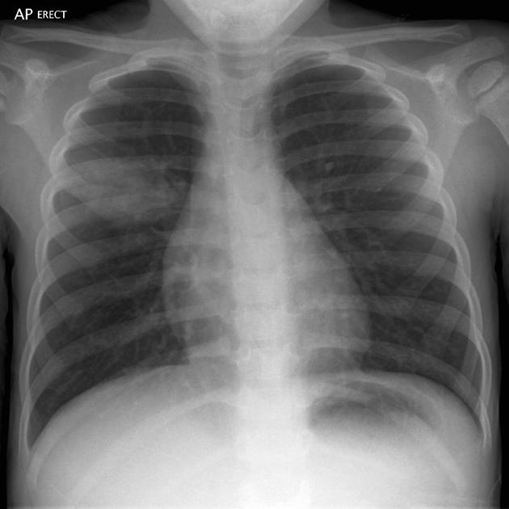
CXR source: http://radiopaedia.org/articles/round-pneumonia-1
ECG showing sinus tachycardia:
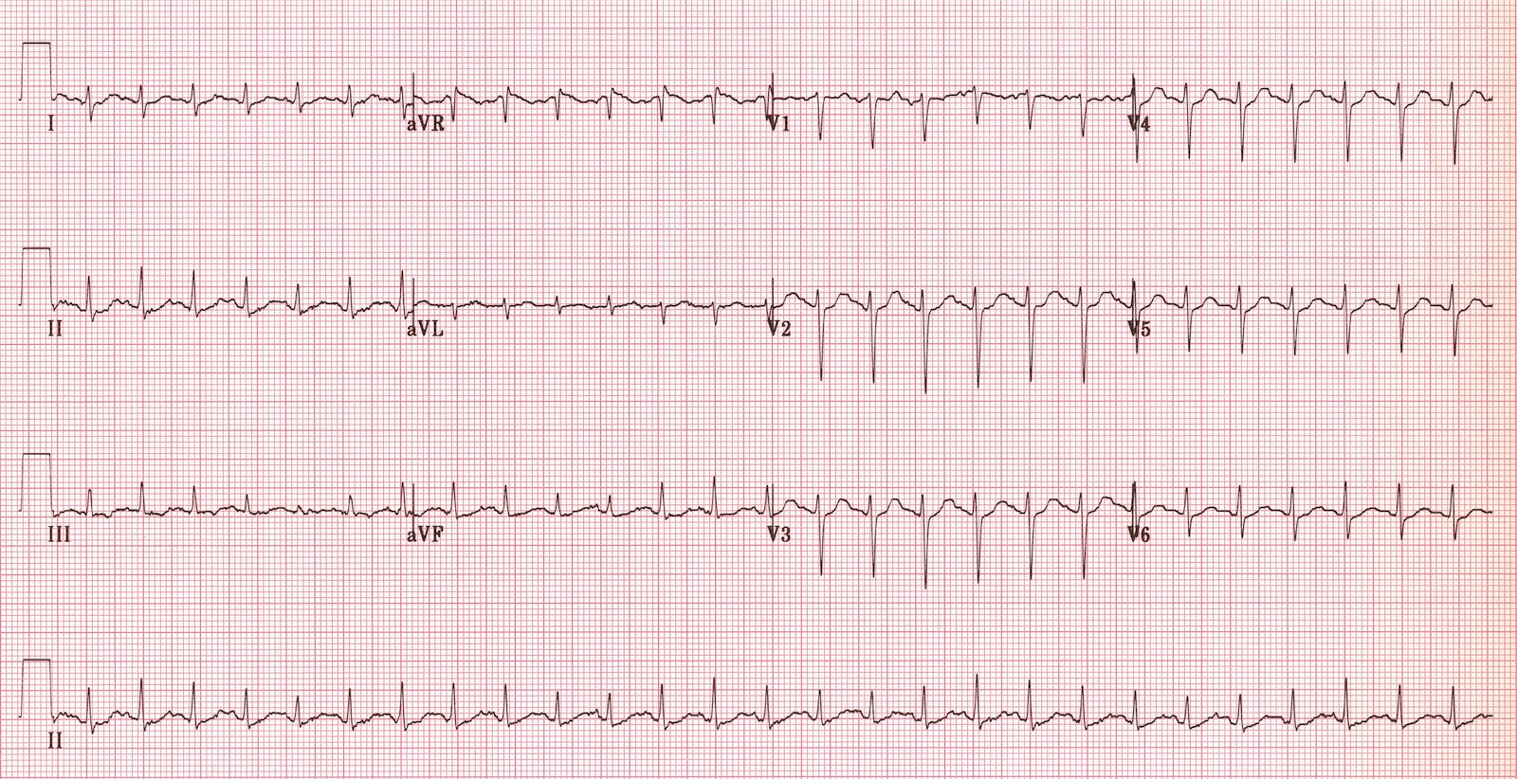
ECG source: http://lifeinthefastlane.com/ecg-library/sinus-tachycardia/

Section VIII: Debriefing Guide

General Debriefing Plan
Individual | Group |  | With Video | Without Video
Objectives
Educational Goal: |  | To allow learners to become more comfortable managing common issues associated with pediatric resuscitation.
CRM Objectives: |  | - Communicate effectively with team regarding orders and drug doses.  - Allocate resources appropriately to manage a distraught parent.
Medical Objectives: |  | - Recognize the need for early IO access in critically unwell child where iv unsuccessful.  - Initiate appropriate investigations and treatment for septic child. Specifically:  - Check capillary blood glucose.  - Administer IV antibiotics.  - Prioritize IV fluid pushes then vasopressors  - Recognize the need to intubate a septic child with altered LOC.
Sample Questions for Debriefing
- How did it feel to perform a resuscitation with a distraught mother in the room? How do you feel the team handled the situation? Do you have any suggestions for how to improve this?
- How did the team approach drug dosing in this child? Did you all feel comfortable with how dosing decisions were made and communicated? What are some ways to calculate weight and dosing when you are uncertain?
- Does everyone feel comfortable putting in an IO? What are the steps? Where you can put it?
- How do you calculate glucose replacement in a child?
- What considerations are required for a pediatric intubation as compared to an adult intubation?
Key Moments
Recognition of need for IO access.
Addressing needs of distraught mother.
Decision to start vasopressors and intubate.

